 **Dr. D. Y. Patil Pratishthan’s**

**DR. D. Y. PATIL INSTITUTE OF ENGINEERING, MANAGEMENT & RESEARCH**

**Approved by A.I.C.T.E, New Delhi , Maharashtra State Government, Affiliated to Savitribai Phule Pune University**

Sector No. 29, PCNTDA , Nigidi Pradhikaran, Akurdi, Pune 411044. Phone: 020–27654470, Fax: 020-27656566  
Website : [www.dypiemr.ac.in](http://www.dypiemr.ac.in) Email : [principal.dypiemr@gmail.com](mailto:principal.dypiemr@gmail.com)

_____________________________________________________________________________________________

**DEPARTMENT**

**OF**

**COMPUTER ENGINEERING**

**LAB MANUAL**

**Lab Practices III**

**(Final Year Engineering)**

**Semester – I**

**Prepared by :** Mrs. Pooja Mishra

Ms. Deepali Jawale



**Institute Vision**

To strive for excellence by providing quality technical education and facilitate research for the welfare of society

**Institute Mission**

1. To educate students with strong fundamentals by providing conducive environment
2. To inculcate research with creativity & innovation
3. To strengthen leadership, team work, professional & communication skills and ethical standards
4. To promote Industry Institute collaboration & prepare students for life long learning in context of technological change.

**Department Vision**

To produce quality computer professionals and fostering research aptitude for dispensing service to society

**Department Mission**

1. To promote growth of an individual by imparting comprehensive knowledge of tools and technologies.
2. To facilitate research and innovation by engaging faculty and students in research activities.
3. To enrich industry-institute interaction in order to provide a platform to know industry demands and motivation for self-employment.
4. To bring forth a conducive environment to enhance soft skills and professional skills to cater needs of society

**Program Specific Outcomes**

1. Professional Skills: The ability to comprehend, analyze and develop software and hardware systems and amp; applications through research, in varying domains.
2. Problem-Solving Skills: The ability to apply standard paradigms and strategies in software project development using open-ended programming environments to deliver a quality product.
3. Successful Career and Entrepreneurship: Adaptation of modern practical and systematic approaches in creating innovative solutions for a successful career, entrepreneurship, and a zest for higher studies.

**Course Objective**

1. Learn effect of data preprocessing on the performance of machine learning algorithms
2. Develop in depth understanding for implementation of the regression models.
3. Implement and evaluate supervised and unsupervised machine learning algorithms.
4. Analyze performance of an algorithm.
5. Learn how to implement algorithms that follow algorithm design strategies namely divide and conquer, greedy, dynamic programming, backtracking, branch and bound.
6. Understand and explore the working of Blockchain technology and its applications.

**Course Outcome**

After completion of the course, students will be able to

CO1: Apply preprocessing techniques on datasets.

CO2: Implement and evaluate linear regression and random forest regression models.

CO3: Apply and evaluate classification and clustering techniques.

CO4: Analyze performance of an algorithm.

CO5: Implement an algorithm that follows one of the following algorithm design strategies: divide and conquer, greedy, dynamic programming, backtracking, branch and bound.

CO6: Interpret the basic concepts in Blockchain technology and its applications

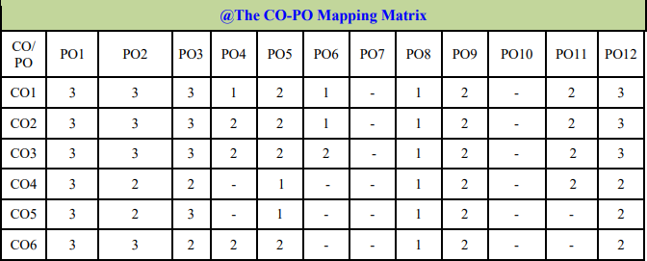

**Guidelines for Students**

Guidelines for Student's Laboratory Journal The laboratory assignments are to be submitted by students in the form of a journal. Journal consists of Certificate, table of contents, and handwritten write-up of each assignment (Title, Date of Completion, Objectives, Problem Statement, Software and Hardware requirements, Assessment grade/marks and assessor's sign, Theory- Concept in brief, algorithm, flowchart, test cases, Test Data Set(if applicable), mathematical model (if applicable), conclusion/analysis. Program codes with sample output of all performed assignments are to be submitted as a softcopy. As a conscious effort and little contribution towards Green IT and environment awareness, attaching printed papers as part of write-ups and program listing to a journal must be avoided. Use of DVD containing student programs maintained by Laboratory In-charge is highly encouraged. For reference one or two journals may be maintained with program prints in the Laboratory.

**Guidelines for Laboratory /Term Work Assessment**

Continuous assessment of laboratory work should be based on overall performance of Laboratory assignments by a student. Assessment of each Laboratory assignment will assign grade/marks based on parameters, such as timely completion, performance, innovation, efficient codes, punctuality, documentation and neatness

**Virtual Laboratory:**

1. <http://cse01-iiith.vlabs.ac.in/>
2. <http://vlabs.iitb.ac.in/vlabs-dev/labs/blockchain/labs/index.php>
3. <http://vlabs.iitb.ac.in/vlabs-dev/labs/machine_learning/labs/index.php>

# Table of Contents

|  |  |  |  |
| --- | --- | --- | --- |
| Sr.No |  | Title of the Experiment | Page No |
| **Group A: Design and Analysis of Algorithms** | | | |
| 1 |  |  |  |
| 2 |  |  |  |
| 3 |  |  |  |
| 4 |  |  |  |
| 5 |  |  |  |
| 6 |  |  |  |
| 7 |  |  |  |
| 8 |  |  |  |
| **Group B : Machine Learning** | | | |
| 9 |  |  |  |
| 10 |  |  |  |
| 11 |  |  |  |
| 12 |  |  |  |
| 13 |  |  |  |
| 14 |  |  |  |
| 15 |  |  |  |
| **Group C : Blockchain Technology** | | | |
| 16 |  |  |  |
| 17 |  |  |  |
| 18 |  |  |  |
| 19 |  |  |  |
| 20 |  |  |  |
| 21 |  |  |  |
| 22 |  |  |  |

**Assignment No. C1**

* **Title:** Installation of MetaMask and study spending Ether per transaction.
* **Objective:** Study and understand Open Source metamask tool to get understanding of ether per transaction.
* **Theory:**

MetaMask is a [software](https://en.wikipedia.org/wiki/Software) [cryptocurrency wallet](https://en.wikipedia.org/wiki/Cryptocurrency_wallet) used to interact with the [Ethereum](https://en.wikipedia.org/wiki/Ethereum) [blockchain](https://en.wikipedia.org/wiki/Blockchain). It allows users to access their Ethereum wallet through a [browser extension](https://en.wikipedia.org/wiki/Browser_extension) or [mobile app](https://en.wikipedia.org/wiki/Mobile_app), which can then be used to interact with [decentralized applications](https://en.wikipedia.org/wiki/Decentralized_application). MetaMask is developed by [ConsenSys Software Inc.](https://en.wikipedia.org/wiki/ConsenSys), a [blockchain](https://en.wikipedia.org/wiki/Blockchain) [software company](https://en.wikipedia.org/wiki/Software_company) focusing on [Ethereum](https://en.wikipedia.org/wiki/Ethereum)-based tools and infrastructure.

MetaMask allows users to store and manage account [keys](https://en.wikipedia.org/wiki/Key_(cryptography)), broadcast transactions, send and receive [Ethereum](https://en.wikipedia.org/wiki/Ethereum)-based [cryptocurrencies](https://en.wikipedia.org/wiki/Cryptocurrency) and tokens, and securely connect to [decentralized applications](https://en.wikipedia.org/wiki/Decentralized_application) through a compatible [web browser](https://en.wikipedia.org/wiki/Web_browser) or the [mobile app](https://en.wikipedia.org/wiki/Mobile_app)'s built-in browser.

Websites or other [decentralized applications](https://en.wikipedia.org/wiki/Decentralized_application) are able to connect, authenticate, and/or integrate other [smart contract](https://en.wikipedia.org/wiki/Smart_contract) functionality with a user's MetaMask wallet (and any other similar blockchain wallet browser extensions) via [JavaScript](https://en.wikipedia.org/wiki/JavaScript) code that allows the website to send action prompts, signature requests, or transaction requests to the user through MetaMask as an intermediary.

The application includes an integrated service for exchanging [Ethereum](https://en.wikipedia.org/wiki/ERC-20) tokens by aggregating several [decentralized exchanges](https://en.wikipedia.org/wiki/Decentralized_exchange) (DEXs) to find the best [exchange rate](https://en.wikipedia.org/wiki/Exchange_rate). This feature, branded as MetaMask Swaps, charges a service fee of 0.875% of the transaction amount.

* **Procedure /Method :**

Here is how to set up and install MetaMask on a desktop browser Download and install the MetaMask extension for your browser

1. Click on the “Get Started” button
2. Select “Create a Wallet” and create a password
3. Write down, store, or memorize your Secret Backup Phrase
4. Confirm your Secret Backup Phrase to ensure you have it correct

Here is how to set up and install MetaMask on mobile devices:

1. Download and launch the MetaMask app from Google Play or the App Store
2. Click on the “Get Started” button
3. Select “Create a Wallet” and create a password
4. Write down, store, or memorize your Secret Backup Phrase
5. Confirm your Secret Backup Phrase to ensure you have it correct

### Download and install MetaMask

The first step is to download the official MetaMask extension, add-on, or application. To set up MetaMask on a mobile device, you will need to visit either Google Play or the App Store. Desktop computer users will need to download the extension or add-on for their browser of choice. MetaMask is currently available for iOS, Android, Chrome (or Brave), Firefox, and Microsoft Edge. Here are the official download links for [MetaMask](https://metamask.io/):

* [App Store (iOS)](https://apps.apple.com/us/app/metamask/id1438144202)
* [Google Play (Android)](https://play.google.com/store/apps/details?id=io.metamask)
* [Chrome (or Brave)](https://chrome.google.com/webstore/detail/metamask/nkbihfbeogaeaoehlefnkodbefgpgknn)
* [Firefox](https://addons.mozilla.org/en-US/firefox/addon/ether-metamask/)
* [Microsoft Edge](https://microsoftedge.microsoft.com/addons/detail/metamask/ejbalbakoplchlghecdalmeeeajnimhm?hl=en-US)

### Getting Started

MetaMask has an on-screen setup tutorial for all users on every supported browser. Follow the instructions, read through the terms, and click “I Agree” to continue the setup process.

### Create Your Wallet

The first step in getting set up with MetaMask is creating a wallet. Click on the “Create a Wallet” button. You will then need to create a password with a minimum of eight characters that you will use to log in to the browser extensions or add-on.

### Secret Backup Phrase

Your Secret Backup Phrase is a way to easily backup and restore your account at any time. It consists of twelve words in a particular sequence. It is essential to memorize this, write it down on a piece of paper and place it in a safe place, or store it in a password manager like [1Password](https://1password.com/) or [LastPass](https://www.lastpass.com/).

Without your Secret Backup Phrase, it will be impossible to restore your account. You can download the phrase and store it on an external encrypted hard drive or storage device for added security. We do not recommend copy and pasting it into a notepad and leaving it on your desktop. If your computer gets stolen, hacked, or someone finds the file, someone can easily log in to your MetaMask wallet.

Confirm your Secret Backup Phrase on the next on-screen prompt when you have it safely stored. This step ensures you have the correct phrase on hand in case you need to restore your account. After confirming your Secret Backup Phrase, click on the “All Done” button. You have now created a MetaMask wallet and are connected to the Ethereum Mainnet.

Those are the complete steps for how you install and set up MetaMask on PC and Mobile for Chrome, Firefox, Microsoft Edge, iOS, and Android.

### How to find your Ethereum address in MetaMask

After installing MetaMask in your browser and the initial setup process is complete, you can click the MetaMask extension or add-on icon from the toolbar. If you are on mobile, just launch the application. The MetaMask interface should now be visible to you, and you will see a string of numbers and letters under “Account 1” near the top of the window. That is your Ethereum address, and you can click on it to copy it to your clipboard.



You can create an unlimited amount of Ethereum addresses under the same account. To achieve this, click on the circle icon on the top right of the interface (or the top middle on mobile). Select the Create Account option, pick an Account Name, and click on the Create button. A new account has a new unique Ethereum address. You can toggle between these by clicking on the same circle icon and selecting your account under My Accounts.



## **How to Sync Metamask Across Devices :**

MetaMask allows you to sync your wallets across multiple devices. To sync your MetaMask mobile app to your MetaMask browser extension or add-on, follow these steps:

1. Open your preferred browser and log in to **MetaMask**.
2. Tap on the **MetaMask icon** from the browser toolbar to open the interface, and click on your icon on the top right.
3. Select the “Settings” option, go to “**Advanced**,” and select “**Sync with Mobile**.” You should see a QR code.
4. Open the **MetaMask mobile application**.
5. Select the “Sync or Import” option and click on “**Scan QR code**.”
6. Scan the QR code with your MetaMask mobile app.



* **Refrances :**
* **Questions and answer :**
* **Conclusion :**

The students got the knowledge of Installation of MetaMask and study spending Ether per transaction.

**Assignment No. C2**

* **Title:** Create your own wallet using Metamask for crypto transactions.
* **Objective:** Is to understand Open Source metamask tool and create own wallet for crypto transactions
* **Theory :**

MetaMask is one of the most popular cryptocurrency wallets. Despite the ups and downs of the market, there are more and more users each year. MetaMask has about 21 million active users each month, 80 times more than in 2019 and significantly more than any noncustodial wallet. This article will explain why this wallet is so popular and its functions. Also, we will describe the development of a cryptocurrency wallet like MetaMask.

## **A Brief introduction to MetaMask**

MetaMask is an open-source, straightforward, and easy-to-use cryptocurrency wallet. It functions as a web browser extension available for Chrome, Firefox, Brave, or a mobile application for iOS or Android. Initially, this wallet supported only Ether and ERC-20 tokens, and now it is compatible with ERC-721 and ERC-1155 token standards. Furthermore, MetaMask benefits include interaction with websites; hence, it can function as a connection node for various DApps on Ethereum.

[Adrian Devis](https://twitter.com/kumavis_) and [Dan Finlay](https://twitter.com/danfinlay) are the MetaMask developers. Their idea was revolutionary and straightforward; they intended to create a web browser extension that would allow managing cryptocurrency and using the browser for fast and secure access with DApps. ConsenSys Software Inc. — a development company, focusing on applications that use Ethereum’s blockchain, implemented the idea in 2016.

The solution used Ethereum’s interface and a web API called [web3.js](https://web3js.readthedocs.io/en/1.0/). This Ethereum library is the fundament of MetaMask since it allows the browser to interact with the local or remote blockchain nodes via HTTP, IPC, and WebSocket; also, it gained the ability to record and read data from smart contracts, transfer tokens, etc. In another way, web3.js allowed the blockchain developers to create proxy and communication bridges between MetaMask, DApps, and the user.

Adrian Devis and Dan Finlay admit that their idea was great. Yet, the technical implementation was super complicated, especially in providing security for the users (web wallets are considered the most vulnerable to hacker attacks). Nonetheless, ConsenSys succeeded, and on the 14th of July in 2016, they offered the first version of MetaMask web browser cryptocurrency wallet for Chrome. Later, they presented a version for Firefox, Brave, and other popular browsers. In 2019 they also launched the mobile version of the MetaMask cryptocurrency wallet.

## **How does the MetaMask wallet function?**

As we mentioned above, the MetaMask cryptocurrency wallet employs the web3.js library to function. This library is a part of the official Ethereum product. The library was developed focusing on the requirements of web applications that could interact with the Ethereum blockchain and take advantage of all blockchain’s benefits and functions.

MetaMask is a cryptocurrency wallet for Ethereum and an instrument that helps to interact with DApps. MetaMask connects the extension to the DApp so that to fulfill both tasks. When the application identifies the MetaMask, it creates a connection, and the user can start using all the features of a specific application.

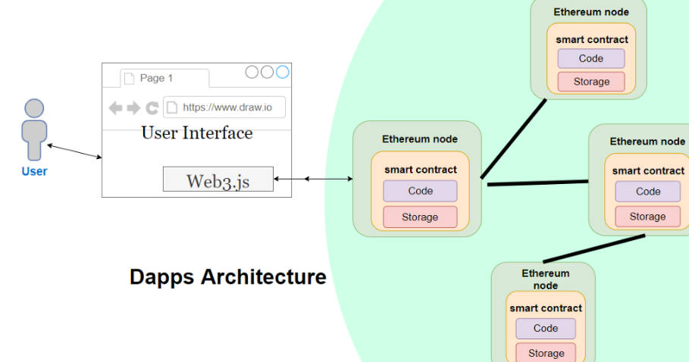

For instance, it can assets trading, access to resources or services, or any other task within the capability of a DApp. Each action has its cost (transaction fee) that must be paid in Ethereum or any specified token. MetaMask wallet has all instruments and protocols for this purpose.

Hence, we can state that Metamusk also controls the interaction of the user and DApp, and processes the operations required for specific actions, besides the function of a wallet. Reliable and secure cryptography and safe internet connection are the environments for these operations.

Furthermore, MetaMask can generate asymmetric keys, store them on a local device, and manage access to the keys. To sum up, MetaMask is a super-safe extension.

## **MetaMask wallet key features**

Easy to use. The first and most apparent benefit of the MetaMask wallet is the ease of use. The wallet offers an intuitive and straightforward user interface that makes the management of cryptocurrencies

and interaction with DApps easier than ever before.

Furthermore, it allows the creation of several wallets. When users create a new wallet, they generate new public and private keys that MetaMask users have fast access.

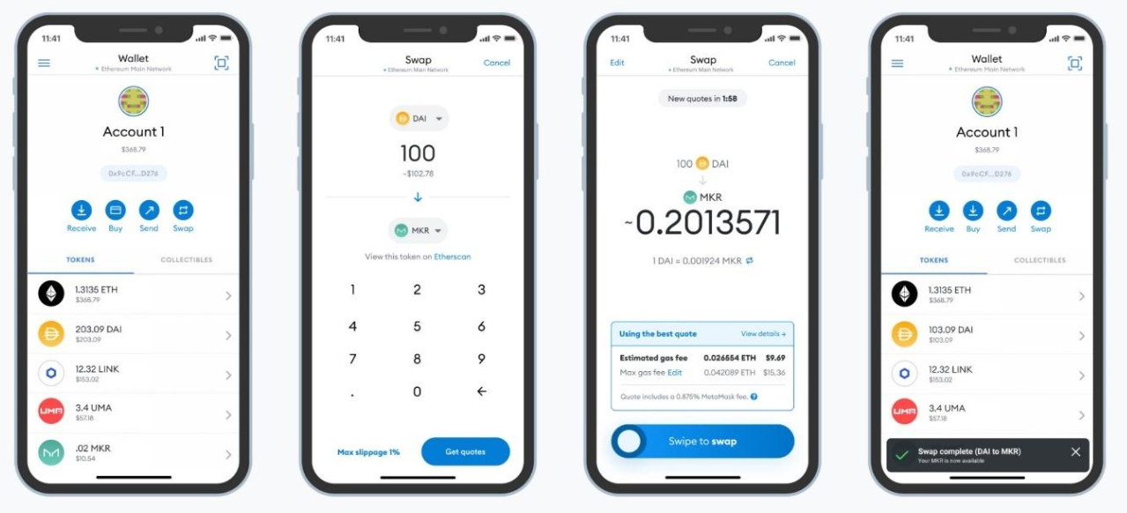

* **Integration with various DApps :**

MetaMask’s users can connect with numerous decentralized applications with a single tap on the screen. It allows them to exchange their tokens swiftly on Uniswap or PancakeSwap exchangers, launch blockchain games like Gods Unchained or Decentraland, buy NFTs on OpenSea or Rarible. All these actions do not require complicated processes. The only movement is connecting the MetaMask cryptocurrency wallet.

* **Integration with other blockchains :**

The additional benefit of MetaMask is that you can join it to other blockchains, e.g., Avax, Polygon, Fantom, Binance Smart Chain (BSC).

* **Hardware wallets support :**

MetaMask service is compatible with hardware cryptocurrency wallets like Ledger, Nano, or Trezor. All you need is to tap the ‘connect a hardware wallet’ button. This is a significant benefit that helps to interact with applications that do not support Trezor and Ledger hardware wallets.

* **Swaps support :**

In 2021 MetaMask offered its users a relatively cheap and fast opportunity to exchange their tokens within the wallet with Swaps. This function supports several automatic marker makers (MM) that help find the best token exchange rate.

* **NFT support :**

MetaMask wallet also allows storing NFTs. When a user buys an NFT on a platform, the token is automatically displayed in the tab of collectible items in the wallet.

## **Main functions of a cryptocurrency wallet**

To develop a cryptocurrency wallet like MetaMask, one should consider two roles of users: regular users and administrators. The average user apparently will use the wallet to store, trade, and exchange tokens. The administrators are the employees responsible for the proper functioning and management of the wallets. Often, they solve the issues of the regular users.

* **Here is a list of functions for regular users:**
  1. **Registration :**It must be easy to create a new profile. The essentials are opening an internet browser, downloading the MetaMask extension from the official website, and coming up with a complicated password. Next, the user will need to put down the seed phrase, and they are ready to go. If one already has a cryptocurrency address, one can easily connect it to the cryptocurrency wallet.
  2. **Applicable exchange rate.** MetaMask displays only the amount of tokens on the account, while other cryptocurrency wallets show the exchange rate for tokens in the investment profile. If you plan to develop a MetaMask crypto wallet clone, it is a sound idea to add these features, which will enhance the user experience of your upcoming project.
  3. **Operations with the cryptocurrency assets.** The main functions of any wallet are transferring, receiving, and exchanging cryptocurrencies; hence, it is vital that these functions are straightforward so that any user is confident in using the wallet. Furthermore, it is an advantage if there is a chance to check the current balance and transaction history. If you have experience trading on an exchange, you will expect MetaMask to display the history of operations and the current balance; yet MetaMask does not offer it. Pay special attention to it if you intend to develop a wallet.
  4. **Favorite addresses.** This is another feature that MetaMask is not showing, while the other wallets do. It allows the users to make a list of addresses for fast token transfers. It is super convenient for minor regular operation fees.
  5. **Employing other blockchains.** After installing the MetaMask extension or application, the user can use only Ether and ERC-20 tokens. However, the users can connect to other blockchains. What is more, they will have a single address for all blockchains.
  6. **NFT support.** Recently, MetaMask wallet also started supporting non-fungible tokens.

Here is a list of necessary functions for platform administrators.

1. T**ools panel :** The administrators can use this tab to trace the current state of the platform, current issues, the number of users, transaction volume, etc.
2. **User management** : This tab helps the administrators track the users' status and manage them: add, delete, block, communicate, verify, etc.
3. **Managing the fees.** It helps to add, delete, or change the transaction fees.
4. **Payment system management**. MetaMask wallet does not offer to link the credit or debit card, PayPal, or another payment system. However, if the wallet offers these functions, the administrators require instruments to manage it.
5. **Content management**. These are the user interface management tools (changing texts, icons, links, etc.).
6. **Connecting Facebook**, Twitter, and Instagram accounts.
7. **Reports and analytics**.
8. **API documentation**

## **Extended functions set for MetaMask clone**

To help your MetaMask wallet clone become famous, you should add some advantages that highlight it from the competitors and improve the user experience.

These can be the following:

* **Linking an account.** Your users will find it useful to be able to buy a cryptocurrency and exchange it for fiat within the wallet. This will be possible if you develop a wallet like MetaMask and add the feature of linking bank accounts, credit/debit cards, PayPal, or other online payment systems.
* **Ecommerce Integrations :** We mean integrating the wallet with exchanges, NFT marketplaces, decentralized applications, shops, and other services that the users might find useful.
* **Multilingual interface :** If you focus on a market where all people speak the same language, you might neglect this aspect. However, your intentions are global, and you should add as many languages as possible to increase the target audience.
* **Push notifications** **:** The notifications will inform the users of receiving payments, ending transactions, rapid exchange rate changes in the investment account, system updates,  suspicious activity, etc.
* **VIP support** **:**Numerous cryptocurrency trading platforms offer support for an additional fee. This may include 24/7 support, communication with a personal specialist, etc.
* **QR scanner** **:**This is another useful feature that allows your users to make payments even faster. Moreover, it will decrease the number of transfers done by mistake.

**Assignment No. C3**

* **Title:** Write a smart contract on a test network, for Bank account of a customer for following operations:
* Deposit money
* Withdraw Money
* Show balance
* **Objective:**
* **Theory :**

Solidity is a high-level language. The structure of smart contracts in solidity is very similar to the structure of classes in object-oriented languages. The solidity file has an extension .sol.

What are Smart Contracts?

Solidity’s code is encapsulated in contracts which means a contract in Solidity is a collection of code (its functions) and data (its state) that resides at a specific address on the Ethereum blockchain. A contract is a fundamental block of building an application on Ethereum.

Example: In the below example, the aim is to deploy a Smart Contract for Marks Management System by using Solidity. In this contract, the details of every student like student ID, Name, Marks, etc can be added and if one wants to give some bonus marks to students then they can also be added. After building the contract all the details of every student can be retrieved.

Approach:

1. The first step is to deploy the smart contract using the Remix IDE. After writing the code compile the code. When it is successfully compiled then deploy it. After deploying the contract a deployed Contract is obtained and then add the student details one by one.
2. If bonus marks need to be added then add in the bonusMarks section after that click on stdCount and fetch the student details to call the stdRecords.
3. Add one or more new student details in this Smart Contract by the increment of stdCount.

* **Implementation:**

Step 1: Open Remix IDE.

Step 2: Click on File Explorers and select Solidity in the environment and create a new file StudentMarksMangmtSys.sol by clicking on New File section.

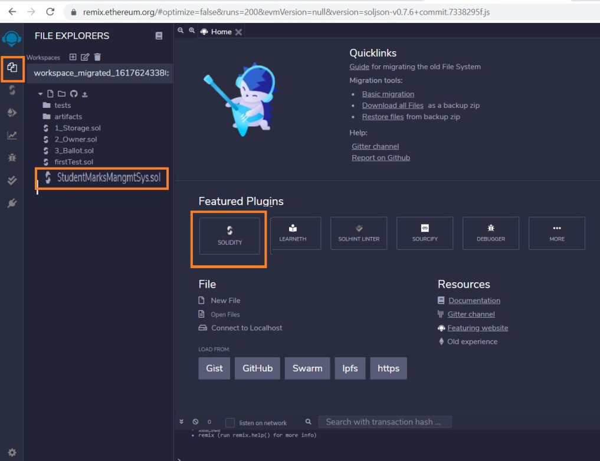

Step 3: Build a smart contract that contains all the details of the student with the help of Remix IDE by clicking on the file name.

// Solidity program to implement

// the above approach

pragma solidity >= 0.7.0<0.8.0;

// Build the Contract

contract MarksManagmtSys

{

// Create a structure for

// student details

struct Student

{

int ID;

string fName;

string lName;

int marks;

}

address owner;

int public stdCount = 0;

mapping(int => Student) public stdRecords;

modifier onlyOwner

{

require(owner == msg.sender);

_;

}

constructor()

{

owner=msg.sender;

}

// Create a function to add

// the new records

function addNewRecords(int _ID,

string memory _fName,

string memory _lName,

int _marks) public onlyOwner

{

// Increase the count by 1

stdCount = stdCount + 1;

// Fetch the student details

// with the help of stdCount

stdRecords[stdCount] = Student(_ID, _fName,

_lName, _marks);

}

// Create a function to add bonus marks

function bonusMarks(int _bonus) public onlyOwner

{

stdRecords[stdCount].marks =

stdRecords[stdCount].marks + _bonus;

}

}

Step 4: After building the contract compile it. Select the compiler version before clicking on Compile button.

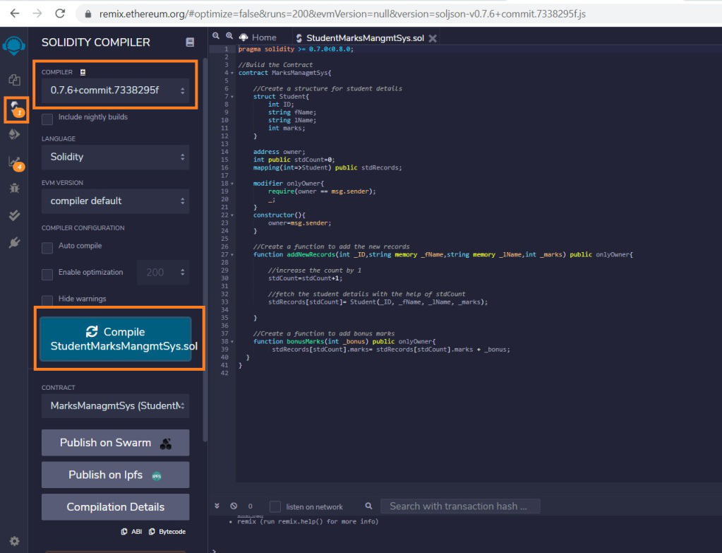

Step 5: After successful compilation, to deploy the contract, select the Environment JavaScript VM (Berlin) before clicking on the Deploy button.

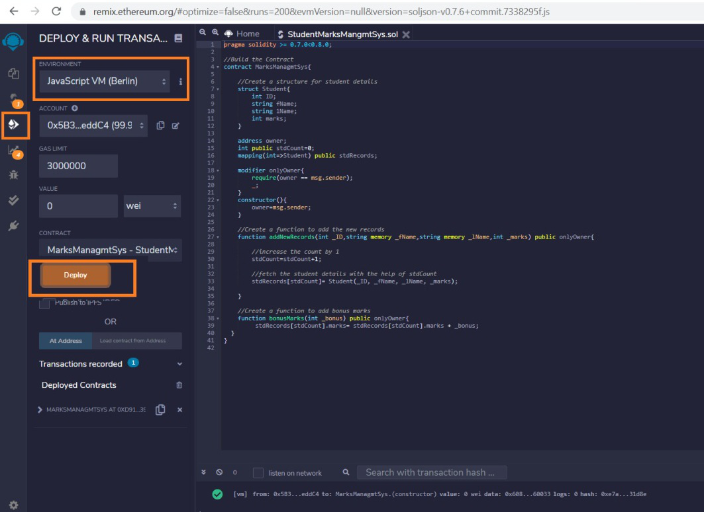

Step 6: If the contract is successfully deployed then deployed contract is obtained. Open the deployed contract and add the student details and transact it.

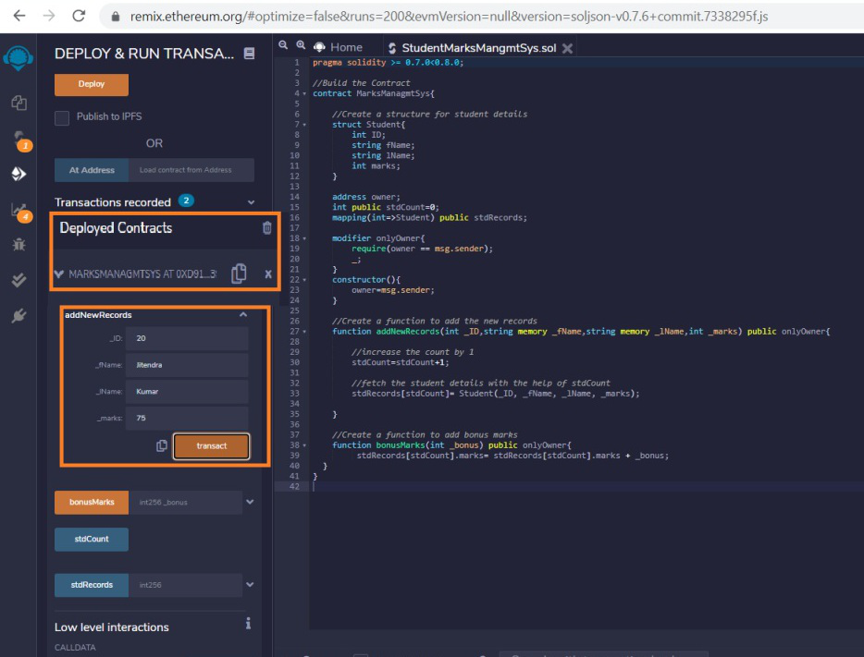

Step 7: Add the bonus marks if you want to give them to the student and transact it after that click on the stdCount. One can see the student details after calling the stdRecords by entering the stdCount.

